**Pave Some Terrain**

Right no0,w our map hardly looks like a "Small cabin in the woods." So we now need to add some terrain to our map. Select the **NoDraw texture**, and then make a new brush, that is **2048x2048x32** in size, and lay this brush just above the floor of the map. Enter the Texture Application tool and select the top side of your new box. Re-paint just this side of the box with the **GrayGrid texture**. This textures helps you see the shape of your terrain. Then select the "**Displacement**" tab, and then press "**Create**". Change the power setting to "**4**". Your new brush object should change into a flat plane with triangles throughout the surface. These triangle are what allow you to sculpt terrain. The power setting allows you to create more detailed terrain.

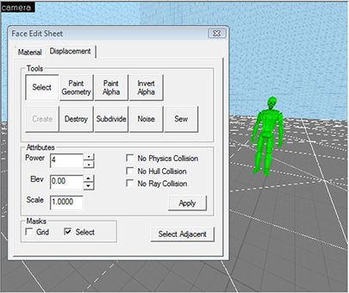

We will be creating a simple hill, so we won't need much detail in our terrain. To start sculpting the terrain select the "**Paint Geometry**" button. We are going to make a flat hill at a set height above our floor that we can then put a cabin on top of. To create the hill select "**Raise to**" and change the distance to **64**and the radius to **64**. Near your map origin, raise up a few areas of the terrain such that you have a small hill to put our cabin onto. You can use the smooth tool to smooth out the edges of the hill. You can also compile the map and get a sense of the shape of your hill in the game.

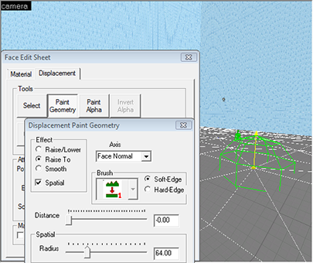

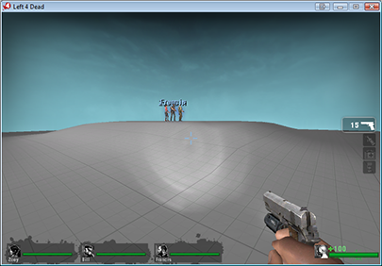

To paint the hill with something that looks more natural, select the material tab, then browse, and search for: "**nature**" in the filter. We are going to select: "**nature/blenddrygrassdirt**" as our material and apply it to the face of the terrain. This is a special material that actually spawns grass automatically, and has a second portion that is dirt without grass. In order for grass to show up properly, you need to change the "**Detail Material File**" setting in the "**Map properties**" window to "**detail/ruraldetailsprites**". Once you do this, you can go to the Texture Application tool, displacement tab, and then select "**Paint Alpha**".

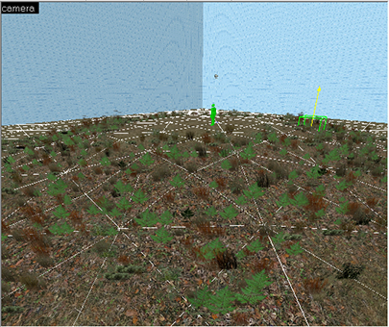

Under effect select "**Raise/Lower**" and then start clicking on the terrain in the 3D window. You should start to see grass pop-up on the terrain. You can right click to remove grass from areas you don't want. You must be careful to only put grass into places that you really need it as the game has a limit in the number of grass objects it can compile. In this case we are just putting grass around the slopes of the hill. This is all we will be doing with the terrain for now.

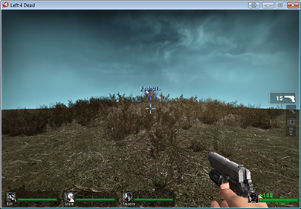

It should be noted that terrain will NOT seal the map, as it is not a convex brush object. Complex terrain will also extend the compile time as the engine has to compute the lighting for each of the triangular surfaces.

### Plant Some Trees

In order to complete the look of our "Small cabin in the woods", we need some woods, or more specifically, some trees and bushes. Trees are grouped in one static model. This means they don't move, but can still collide with players and bullets. Inside Hammer they are a point entity named "**prop_static**".

To place a tree: open the entity tool by pressing **SHIFT+E**. Change the "**Objects**" setting in the bottom right to "**prop_static**" and then click inside the 3D window. You should end up with a little red cube. This little red cube doesn't yet have a model assigned to it. Go back to the selection tool, and then right click on the cube in a 2D window and select "Properties" or press **ALT+ENTER**. In the properties window select "**World Model**" then press "**Browse**". The model browse window pops up. This window is your link to all the props inside Left 4 Dead. It has a similar filter search window to the material browser. For this model type in "tree". We are going to select "**props_foliage\trees_cluster02.mdl**".

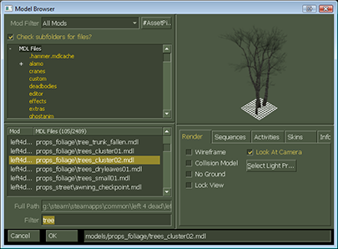

This object is going to setup the outermost ring of trees on the edges of my map. Click "OK", then "Apply". You should now have a set of trees visible in your 3D window. They may or may not have leaves rendered depending on your graphics settings. You can now make copies of this model by simply copying and pasting. We use the keyboard shortcut **CTRL+C** and **CTRL+V**. All you do is aim your mouse as a new spot in the 3D window and paste a new tree. We suggest changing the rotation of each new tree to get a bit more variety in your forest.

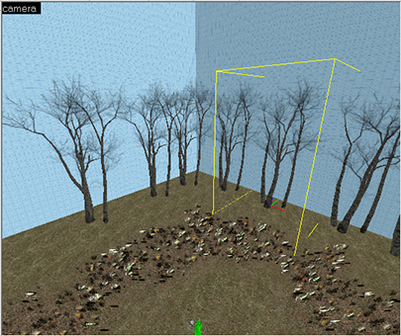

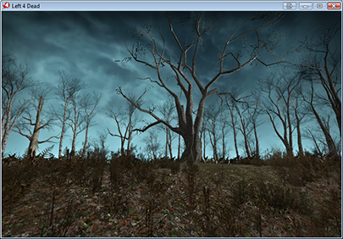

Keep in mind that the more unique models you have in your level the slower the game will run, as each new model has to load a new texture and geometry into memory, and the more objects you have the longer your compile time will take. If you study the maps made by Valve you will see that they have carefully planned out each map. They place detail only in places the players can go. And the further aware from the main path the players travels the less detail you should add.

COMMENTS Login or register to post comments

avatar

C-map

Submitted by linktocomputer on Tue, 01/26/2010 - 3:56am

C-map - Authorized distributor of c-map, c-map max, c-map nt+, navionics, livecharts, SeaPro

toyota parts

Login or register to post comments

avatar

importing materials

Submitted by J_man86 on Sat, 01/16/2010 - 11:06am

I'm trying to import the materials from l4d but when in sketchup under the plugin tab there is only 2 options in the drop down menu and they are both "export", so i don't know how to import the materials. please help.

Login or register to post comments

avatar

Re: Custom props

Submitted by ZapWizard on Tue, 12/29/2009 - 12:41pm

You package the custom props along with your final VMF, which is a sort of ZIP style packaged file with all the files related to your map or campaign.

Login or register to post comments

avatar

Great Work - Thanks!

Submitted by SMTB1963 on Tue, 12/29/2009 - 6:48am

After initially reading this article soon after it was published, I went searching for more L4D "how-to" stuff on the net...this is by far the best written & explained tutorial for those new to L4D modding I've found so far. Also, the links to the tools & utilities were great time savers.

Thanks MAXIMUMPC and Joshua Driggs!

ps - anyone reading this should check out ZAPWizard's other projects - he's definately into some cool stuff.

Login or register to post comments

avatar

Yellow Cubes

Submitted by mdpaustin on Thu, 12/24/2009 - 8:24pm

Pikalex,

Go to:

Tools->Options->3dViews

Increase the Model Render Distance and see if that solves the problem.

Login or register to post comments

avatar

custom props

Submitted by jackmueth on Wed, 12/23/2009 - 8:57pm

when using a custom prop, do i have to install the prop on every computer i use it on, or does the map save the model info within it?

Login or register to post comments

avatar

Yellow cubes instead of models?

Submitted by pikalex88 on Tue, 12/22/2009 - 6:52pm

This looks like a very interesting and detailed tutorial, but I'm having a problem on page 2. When I place the static prop tree models in the 3D window they appear as giant yellow cubes and I cannot actually see the tree model unless I move the camera inside the box, where it cannot see other models. In the picture from the tutorial multiple trees can be seen, how is this possible? Does anyone else have this problem or know what I'm missing? I also cannot see grass after I paint alpha within the 3D window, though when I run the game it is there. That isn't as big a problem, but could maybe be related?

A screenshot of my map running in Hammer if that helps is Here

Login or register to post comments

avatar

Did you make the outer most

Submitted by ZapWizard on Tue, 12/29/2009 - 12:44pm

Did you make the outer most cube of your world hollow?

As for the grass: Along the menu bar there is a setting to view everything as high quality, grass and leaves are hidden in all but the highest quality setting.

Login or register to post comments

avatar

"Fix the roof line"

Submitted by klewd on Tue, 12/15/2009 - 7:33pm

This is one of the best tutorials I've read, but unfortunately there is one point where I think it could be better explained. How do you make everything align suddenly at page 8? It's not aligned at page 7, and there's no prior explanation, that I can see at least.

Login or register to post comments

avatar

It is explained in the first

Submitted by ZapWizard on Sun, 12/20/2009 - 7:38am

It is explained in the first paragraph on page 8. What you need do is to cut the face at the edge of the balcony and then pull it out until the center of the roof line meets close to the center of the top of the block.

Login or register to post comments

avatar

Zap, first thanks for the

Submitted by mdpaustin on Sun, 12/20/2009 - 6:26pm

Zap, first thanks for the great tutorial. I too was having difficulty getting the roof center line adjusted. Once I clicked on "Project textures from photo" again, everything worked out.

M

Login or register to post comments

avatar

Wow

Submitted by emperor3d on Thu, 12/10/2009 - 9:29pm

You gotta give major props to MPC for this rather thorough tutorial. Very fine job indeed. Good job boys and girls.

Login or register to post comments

avatar

how

Submitted by hammerfell on Thu, 12/10/2009 - 8:06am

btw how different would this be from l4d2? can we do this using roughly the same process in l4d2?

Login or register to post comments

avatar

Just the same.

Submitted by ZapWizard on Fri, 12/11/2009 - 7:30am

I actually am in the beta for the L4D2 SDK, the steps to make a map and import assets is just the same as for L4D1.

Login or register to post comments

avatar

The maps you create will

Submitted by willsmith on Thu, 12/10/2009 - 12:19pm

The maps you create will work in L4D2 when the SDK comes out.

Login or register to post comments

avatar

Wow, one of the BEST

Submitted by Xylogeist on Thu, 12/10/2009 - 7:54am

Wow, one of the BEST how-to's by far.

Login or register to post comments

avatar

Too bad nobody actually

Submitted by lunchbox73 on Thu, 12/10/2009 - 7:04am

Too bad nobody actually plays Left 4 Dead anymore. Even weeks before the sequel there were hardly any games out there. Almost impossible to get a full versus game going.

Login or register to post comments

avatar

This guide will also work

Submitted by ZapWizard on Fri, 12/11/2009 - 7:45am

This guide will also work for the L4D2 SDK, or really any Source based game.

Login or register to post comments

avatar

No kidding, and this was

Submitted by DBsantos77 on Thu, 12/10/2009 - 8:43am

No kidding, and this was when STEAM had a $7 special on the first one.

:/

-Santos

Teh Rig:

AMD Phenom 720 (Unlocked to Quad, Stable @ 3.6 Ghz 1.47v)

Gigabyte Micro ATX 785gx Motherboard

G.Skill 4GB 1333 DDR3 8-8-8-21 @ 1.6v

HIS ATI Radeon HD4670 (CCC OC'd)

550w Corsai

Login or register to post comments

avatar

kudos

Submitted by hammerfell on Thu, 12/10/2009 - 6:21am

Definitely one of the coolest how too articles ever! I'm totally making my house Into an L4D level... and then after that... My friend's house... and after that... anything I can get blue prints and pictures of O_O

Login or register to post comments

avatar

work

Submitted by Yusonice on Thu, 12/10/2009 - 4:51am

Too much work!

Ill sticck to downloading the maps

Login or register to post comments

avatar

Great level of detail. Now

Submitted by Veritas19 on Wed, 12/09/2009 - 9:57pm

Great level of detail. Now do one for Team Fortress 2!

Login or register to post comments

avatar

This has to be the most epic

Submitted by vistageek on Wed, 12/09/2009 - 9:27pm

This has to be the most epic and well done how to i have ever seen. Great job. Tanks so much! (pun intended)

Login or register to post comments

avatar

This is sick, is there

Submitted by DBsantos77 on Wed, 12/09/2009 - 7:45pm

This is sick, is there anyway to achieve this by making models in 3DS or Maya?

-Santos

Teh Rig:

AMD Phenom 720 (Unlocked to Quad, Stable @ 3.6 Ghz 1.45v)

Gigabyte Micro ATX 785gx Motherboard

G.Skill 4GB 1333 DDR3 8-8-8-21 @ 1.6v

HIS ATI Radeon HD4670 (CCC OC'd)

550w Corsai

Login or register to post comments

avatar

or

Submitted by nekollx on Thu, 12/10/2009 - 3:24pm

or Daz/Cararra/Poser?

------------------------------

Coming soon to Lulu.com --Tokusatsu Heroes--

Five teenagers, one alien ghost, a robot, and the fate of the world.

Login or register to post comments